DNA Fingerprinting Quiz Name:___________________________________

1. Why do we use a restriction enzyme during DNA fingerprinting?

2. What is the purpose of heating the DNA and the enzyme?

3. How many samples of DNA should go in each well in the gel?

4. Is the DNA molecule negatively or positively charged?

5. After DNA samples are loaded into the sample wells, they are “forced” to move through the gel matrix. What size fragments (large vs. small) would you expect to move toward the opposite end of the gel most quickly? Explain.

6. You are using a restriction enzyme that cuts at the CCGG. Cut between the C and G. It does not leave sticky ends. Show where it would cut on this DNA strand. Count the number of base pairs in each band. Using a chart like the one below the DNA strands mark draw the bands for each of the strands of DNA shown.

Suspect 3
GTCGACCGGTGACCGTGCGTACACAGTGCTCCGGATAGCTGATAGCTCCGGTG CAGCTGGCCACTGGCACGCATGTGTCACGAGGCCTATCGACTATCGAGGCCAC

Suspect 4
GTCTCCATCCGGACTACCATACATCTGGTGTACCCGGTGATATCGTCCGGGTG CAGAGGTAGGCCTGATGGTATGTAGACCACATGGGCCACTATAGCAGGCCCAC

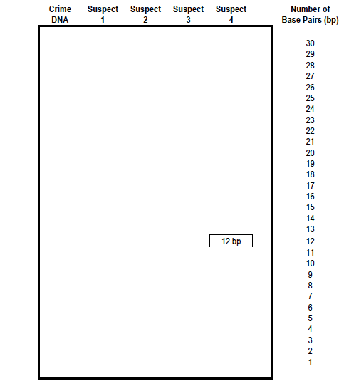

Case 1
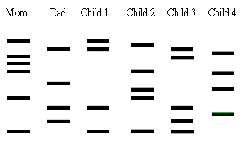
Mr. Chan’s family consists of mom, dad and four kids. The parents have one daughter and one son together, another daughter is from the mother’s previous marriage, and the other son is adopted. Here are the DNA analysis results:

7.Which child is adopted? Why?

8.Which child is from the mother’s previous marriage? Why?

9.Who are the own children of Mr. and Mrs. Chan?

10. The following DNA sequence is from a virus that is dangerous, scientists want to use a restriction enzyme to cut the virus into bits. They do not need sticky ends because the do not plan to combine it with other DNA. The enzyme used cuts at the following location GTC ↓GAC. Show how this DNA would be cut on the DNA below.

11. How many pieces would you have? ________

12. How long (number of base pairs) is each of the fragments?

G A A A A G T C G A C A A G G C A G T C G A C T T T T A A A A G T C G A C A T G C
C T T T T C A G C T G T T C C G T C A G C T G A A A A T T T T C A G C T G T A C G

13. This enzyme cuts at the following location GTC ↓GAC. Show how the DNA would be cut on the DNA below.

14. How many pieces would you have? ________

15. How long (number of base pairs) is each of the fragments?

ACGACGTAGTCGACTTATTAT GTCGACCCGCCGCGTGTCGACCATCA
TGCTGCATCAGCTGAATAATACAGCTGGGCGGCGCACAGCTGGTAGT

